# Debugging Exercises

Name:  
Campus:

## Exercise 1: Run the Debugger

Run the Debugger Upload a screenshot of Visual Studio running in debug mode.

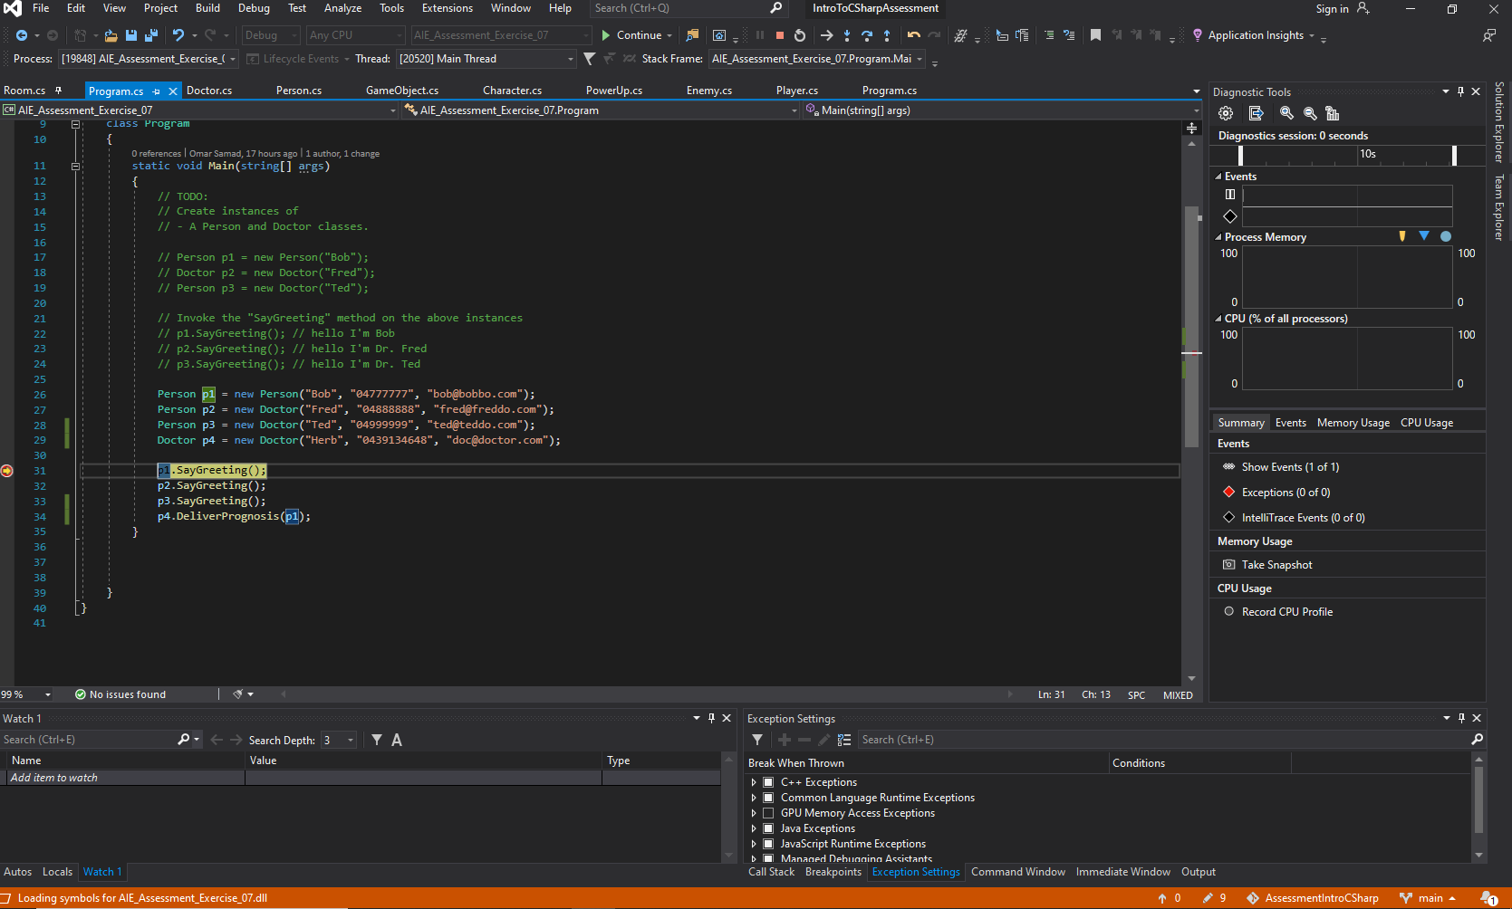

## Exercise 2: Compiler Errors

Upload a screenshot of 3 different compiler errors. Write a brief description of what each error means.

|  |  |
| --- | --- |
| **Screenshot** | **Error Description** |
|  | A compiler error occurred because the SayGreeting() method does not take 1 argument – it takes no arguments. |
|  | A compiler error occurred because the index of the forloop was out of range – the size of the collection was less than the forloop index.  Changing “<=” to “<” will fix this compiler error. |
|  | If statements  need to be bool types.  In this screenshot, the if statement reads “if (number = 50)”. This is not a bool type, it is an int type and therefore the compiler will not run. |

## Exercise 3: Reference Material

List at least one website that provides material to aid you in understanding the C# Language.

<https://stackoverflow.com/>

## Exercise 4: Using the Debugger

Upload a screenshot showing.

* A breakpoint

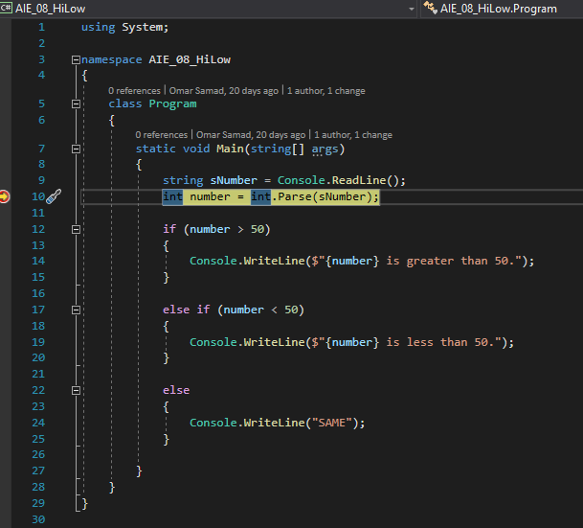

* A variable watch

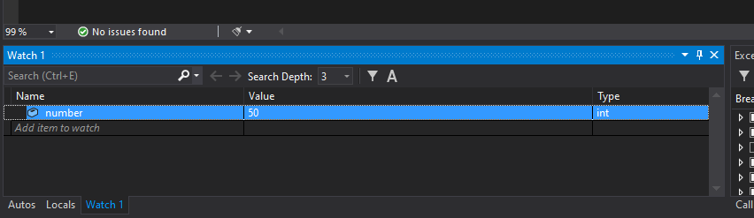

* The call stack

